Zachary Orton
3/29/2023
PS# 7
P1)

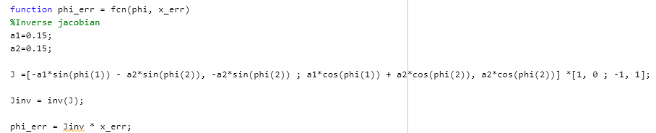
Jacobian Inverse Control

Compare:
We see really close results to the ones we saw in PS5 with the normal PD control and feedforward in joint space, operational space may be slightly worse when directly comparing RMSE.

P2.1)

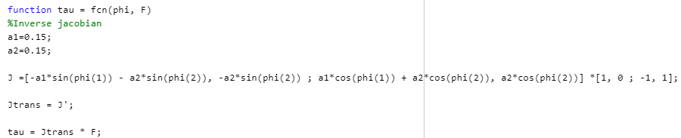
Jacobian Transpose Control

P2.2)

I

Inverse Dynamics Control in Operational Space
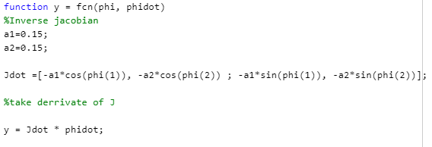
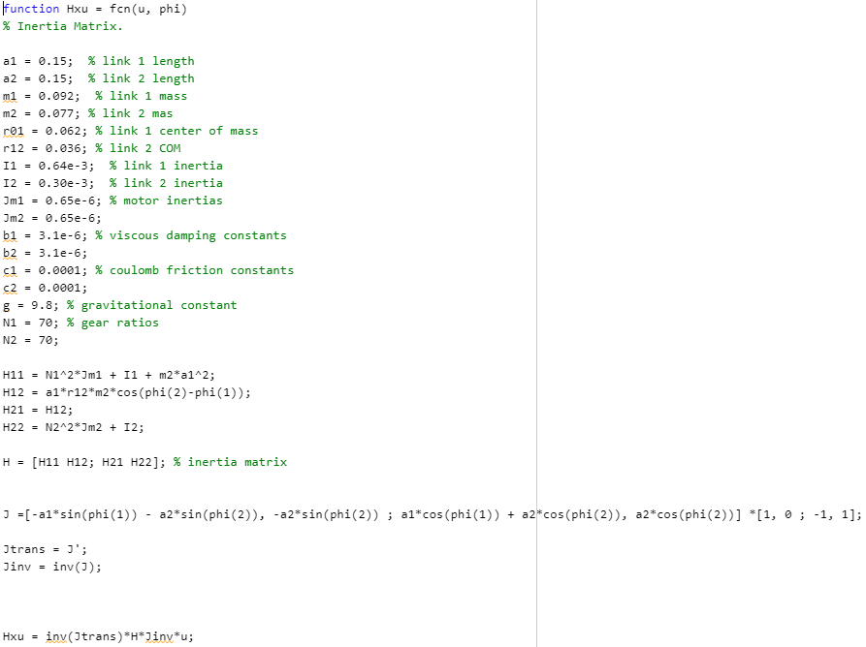

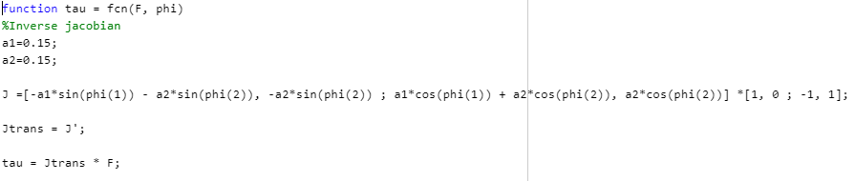

P2.3)
Robust Control in Operational Space

Compare: Just like we have seen before IDC is better than PD and sliding control with IDC gives us the best tracking, we see the same results here in operational space.
Appendix:
Code:
%Zachary Orton Plotting Script
close all
%Plot actual end effector trajectory
figure(1)
plot(xy(:,1) , xy(:,2), 'b')
grid on
grid minor
hold on

%Plot desired end effector trajectory
plot(xy_d(:,1) , xy_d(:,2), '--r')
ylabel("Y [m]")
xlabel("X [m]")
title("End Effector Trajectory")
legend("Actual", "Desired")
axis([0 0.25 0 0.2])

%Add the circle speed to the plot
text(.02,0.02, sprintf("Speed: %.1f", speed))

%%
% %Get joint errors in degrees
% jerrDeg = rad2deg(errors.signals.values);
% Jointerror1 = jerrDeg(:,1);
% Jointerror2 = jerrDeg(:,2);
%
% % Root Mean Squared Errors & Max Errors
% RMSE1 = sqrt(mean((Jointerror1).^2));
% RMSE2 = sqrt(mean((Jointerror2).^2));
% RMSE = [RMSE1 , RMSE2];
% MaxError1 = max(abs(Jointerror1));
% MaxError2 = max(abs(Jointerror2));
% MaxError = [MaxError1, MaxError2];
%
% figure(2)
% %plot joint errors vs time
% plot(errors.time , Jointerror1, 'b')
% grid on
% grid minor
% hold on
% plot(errors.time , Jointerror2, '--r')
% ylabel("Error [Deg]")
% xlabel("Time [s]")
% title("Joint Errors vs Time")
% legend("Joint 1", "Joint 2")
% %add text about speed
% text(0.09, -MaxError(1)*.95, sprintf("Speed: %.1f", speed))
% text(1, -MaxError(1)*.75 , sprintf("RMS Error = [%.3f°,%.3f°]", RMSE(1), RMSE(2)))
% text(1, -MaxError(1)*.85, sprintf("Max Error = [%.3f°,%.3f°]", MaxError(1), MaxError(2)))

%%
%OpS Error

Opserror1 = OpsError.signals.values(:,1);
Opserror2 = OpsError.signals.values(:,2);

% Root Mean Squared Errors & Max Errors
ORMSE1 = sqrt(mean((Opserror1).^2));
ORMSE2 = sqrt(mean((Opserror2).^2));
ORMSE = [ORMSE1 , ORMSE2];
MaxOpsError1 = max(abs(Opserror1));
MaxOpsError2 = max(abs(Opserror2));
MaxOpsError = [MaxOpsError1, MaxOpsError2];

figure(3)
plot(OpsError.time, Opserror1, 'b')
grid on
grid minor
hold on
plot(OpsError.time, Opserror2, '--r')
ylabel("Op-Space Error [Deg]")
xlabel("Time [s]")
title("Op-Space Errors vs Time")
legend("OpS Error 1", "Ops Error 2")

text(0.09, MaxOpsError(1)*.95, sprintf("Speed: %.1f", speed))
text(1, MaxOpsError(1)*.85 , sprintf("RMS Error = [%.3f,%.3f]", ORMSE(1), ORMSE(2)))
text(1, MaxOpsError(1)*.75, sprintf("Max Error = [%.3f,%.3f]", MaxOpsError(1), MaxOpsError(2)))

